Broccoli Information Pack
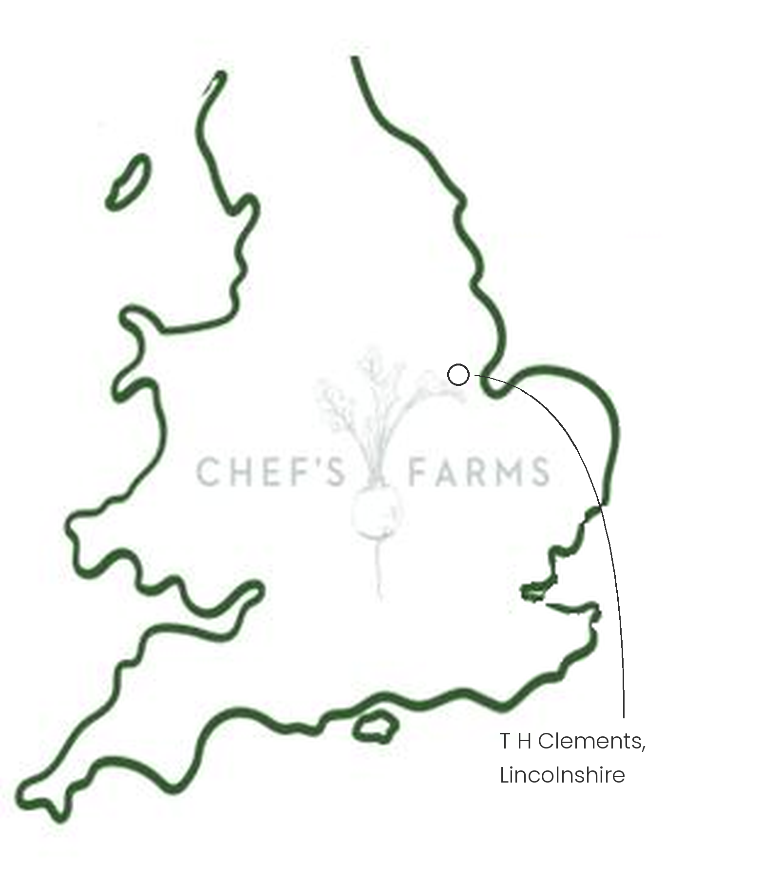
Introduction
Broccoli, also known as calabrese, is a brassica grown for its tight green head of flower buds. The name calabrese comes from Calabria in southern Italy, but it grows very well in the UK through the summer and autumn.
Farm Information
Our broccoli is grown by T H Clements in Lincolnshire, who also supply our savoy, white cabbage, spring greens and swede.
Lincolnshire is one of the UK's great vegetable growing regions, with flat, fertile soils that suit brassicas well. Broccoli grows fast once planted out, and each head is cut by hand at the right moment, before the buds begin to open. Because heads in the same field mature at slightly different times, the crop is picked over several passes.
As a brassica, broccoli shares pests and diseases such as cabbage white caterpillars, aphids and clubroot with the rest of the family. Rotating brassicas around the farm, so they only return to the same field after a break, stops these building up in the soil.
We are proud to work with the team at T H Clements.
More
The UK season runs from early summer into late autumn. Don't waste the stalk: peel the tough outer skin and slice it, as it is sweet and tender inside. Florets are best blanched briefly or charred hard in a hot pan.
Nutritionally, broccoli is a good source of vitamin C, vitamin K, folate and fibre.
Media
See shared album

